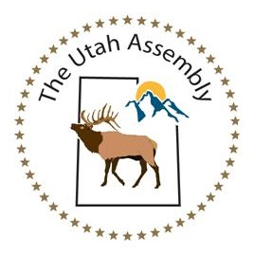
Letter of Intent and Conduct Becoming an
American State National or American State Citizen
I declare that I am not a member of any Law Enforcement Agency or Public Agency of the Federal, State, City, County or Township Agency.

The Utah Assembly consists of willing and able volunteers.

I declare to conduct myself with honor, respect, peace, and love as I help self-govern while treating my fellow Living Men and Women in the same manner as I conduct myself. Education and the sharing of facts shall be always a primary activity.

I understand my right to assemble, the plan for reconstructing our lawful government, and the role of an assembly member, as well as the role of the Federation, The United States of America unincorporated.

I have studied the paperwork process and have knowledge enough that: each Assembly member has autographed their name and sealed their own documents to declare their status and rebut any corporate presumptions.

I volunteer to support the Assemblies and I will do no harm while providing my ideas, skills, and talents to those places where they are most needed. I will never forget that we will stand united against any foreign or domestic activity attempting to destroy the good work that has been diligently and lovingly accomplished.

I understand as an American State National or American State Citizen on the Land & Soil Jurisdiction, I agree to allow the Assembly to use lawful process and procedures in any course correction that might be needed. Challenges to any foundational documents are to be directed to Fiduciary: Anna Maria Riezinger, email: avannavon@gmail.com

I volunteer to donate all I can, to the best of my ability, to The Utah Assembly, while conducting myself with honor, respect, peace and love in keeping the Peace and upholding the Public Law.

By:____________________________ Email:_______________________________
Date:___________ Phone:______________________________

